AI Enabled Conversational IVR Modernization Framework

Author: Nalleboina Sravanthi
Date: 15 February 2026
Version: Milestone 1

Contents
Introduction 3
What is IVR? 3
Architecture: 3
What is Twilio? 4
How Twilio is Used in the IVR? 4
What Kind of XML Instructions? 4
How Workflow Happens 4
How do Loops Work in Twilio? 5
Twilio Architecture: 5
Use Case (IRCTC): 5
Scalability of the Proposed System 5
Primary Issues Requiring Custom Development 7
Why Custom Development is Needed 7
Legacy IVR – Technical Challenges in Current Market Trends 7
Real-Time Data Handling Challenges 8
Limitations / Requirements of Particular Cloud Platforms 8
Compatibility and Feature Gaps 9
Security and Privacy Challenges 9
Scalability Challenges 9

Introduction
The AI Enabled Conversational IVR Modernization Framework focuses on improving traditional IVR systems by making them more intelligent and user-friendly with the help of Artificial Intelligence. Instead of forcing users to follow long menu options or press multiple keys, the system allows people to speak naturally and get the help they need. Using technologies like speech recognition and natural language processing, the system can understand user requests and provide accurate responses. This project aims to make customer interactions faster, easier, and more efficient, while also reducing the workload on human support team. The overall goal is to create a smarter IVR system that delivers a better experience for both users and organizations.

What is IVR?
Interactive Voice Response (IVR) is an automated phone system that allows callers to get information or perform tasks using voice commands or keypad inputs. It helps customers solve common issues without speaking to an agent. If needed, the call is transferred to the appropriate support person. This improves call handling and reduces waiting time.
Modern IVR systems use AI to understand what callers say instead of relying only on keypad inputs. Customers can speak their needs, and the system responds instantly. This makes it easier for users to get help on their own and reduces call load, wait time, and costs for businesses.

Architecture:
When a caller dials the system, the call is first received by a cloud telephony platform such as ACS or Twilio. The caller’s voice is converted into text using Speech-to-Text technology. This text is then sent to the Conversational AI engine, which understands what the caller wants and decides the best response. If needed, the system connects to backend services and business databases to fetch or update information. The response is converted back into voice using Text-to-Speech and played to the caller. This process happens in real time, allowing smooth and natural conversation.

What is Twilio?
Twilio is a cloud communications company that helps businesses send messages, make phone calls, and build communication features into their apps and websites.
Twilio provides tools and APIs that developers can use to add voice calling features to applications. It also supports sending and receiving SMS and WhatsApp messages. Twilio offers email communication services and helps in building IVR (Interactive Voice Response) systems. In addition, it is commonly used to generate and send OTPs and verification codes for secure user authentication.

How Twilio is Used in the IVR?
Twilio allows you to create and run an IVR system using the cloud, so no physical phone equipment is needed.
When a customer calls your Twilio phone number, Twilio receives the call and sends it to your IVR application. The IVR application contains the rules for what the system should say and how it should respond to user inputs. The application sends simple instructions to Twilio, and Twilio follows those instructions during the call.
If required, the IVR application can connect to a database to get or store customer information. When the IVR cannot handle a request, Twilio transfers the call to a live agent.
Flow: Caller → Twilio Number → IVR Application → Database → Agent (if needed)

What Kind of XML Instructions?
In TwiML, you use verbs (commands). Each verb tells Twilio to perform an action.
Command Voice Verbs like <Say>, <Gather>, <Dail>, <Pause>, <Redirect>, < hangup>.

How Workflow Happens
When someone calls:
- Twilio receives the call.
- Twilio requests instructions from your server.
- Your server returns TwiML (XML).
- Twilio executes the instructions.
- If input is needed, Twilio sends data back to your server.
- Server responds with new TwiML.
This process continues until the call ends.

How do Loops Work in Twilio?
Twilio does not have traditional programming loops like for or while.
Instead, loops happen using: <Redirect>

Twilio Architecture:
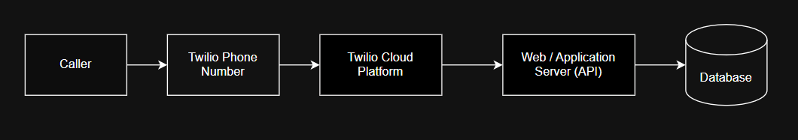

Use Case (IRCTC):
Modern IVR Integration with Traditional IVR
IRCTC already has a traditional IVR system where passengers listen to menu options and press keys to get information such as PNR status or ticket details.
In the proposed system, a modern AI-enabled IVR using Twilio is added on top of the existing traditional IVR. The modern IVR becomes the first point of interaction for callers.
When a passenger calls, the modern IVR tries to understand the request using voice. If it can handle the request, it gives the response directly. If it cannot, the call is forwarded to the traditional IVR or to a live agent.
This approach allows IRCTC to modernize gradually without removing the existing system.

Scalability of the Proposed System
The system is cloud-based, so it can easily grow with demand.
- Can handle large number of calls
- No physical hardware upgrade required
- Automatically scales during peak travel seasons
- Suitable for nationwide usage
Adding New Features Apart from Existing Ones
- New services can be added by simply creating new AI intents and connecting them to backend systems. We can add like Train schedule enquiry, Seat availability, Ticket cancellation, Refund status and Coach position.
Do They Use Twilio / ACS / BAP?
Large organizations like IRCTC usually follow a hybrid approach:
Twilio is chosen because it easily supports voice, AI integration, and SMS.
How Integration Is Done
Integration is done using APIs.
- Twilio receives the call
- Call is sent to modern IVR application
- Modern IVR sends voice/text to AI engine
- AI connects to IRCTC backend APIs
- Response is returned to Twilio
- Twilio plays voice response or sends SMS
Latest Architecture for IRCTC Use Case
- Twilio Cloud Telephony
- Modern Conversational IVR
- AI Engine
- IRCTC Backend APIs
- Text-to-Speech
- Passenger
- If failure → Traditional IVR / Live Agent
Various Integration Phases
Phase 1 - Parallel Integration
Modern IVR and traditional IVR run together.
Phase 2 – Partial Migration
Common services managed by modern IVR.
Phase 3 – Full Modernization
Most services managed by modern IVR. Traditional IVR kept as backup.
Customized Workflow
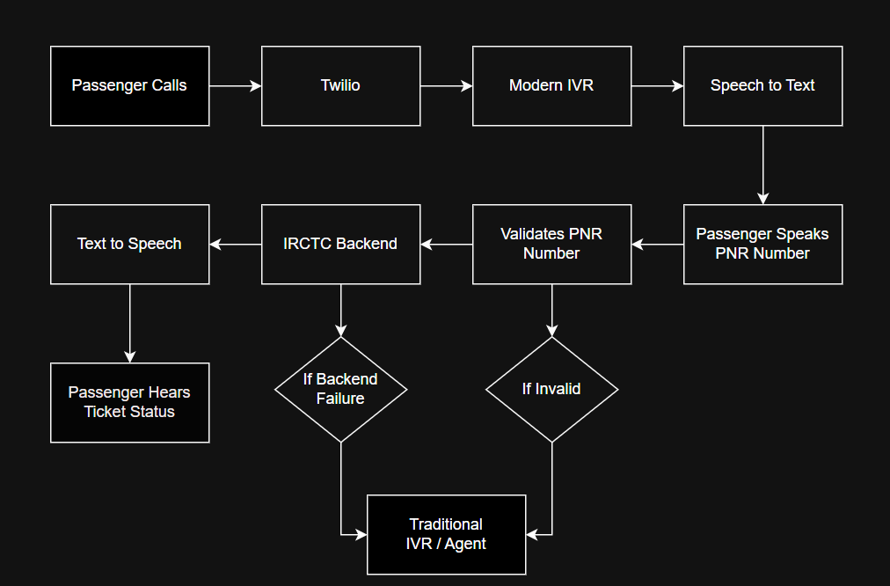

Primary Issues Requiring Custom Development
While platforms like Twilio provide many built-in features, custom development is still required to meet IRCTC-specific needs.
Key Challenges
- Designing conversation flows for Indian users and multiple languages.
- Building intent recognition for railway-specific terms (PNR, RAC, WL, coach, seat)
- Creating secure authentication logic (OTP / Caller ID)
- Integrating with IRCTC backend APIs
- Managing large traffic during peak seasons

Why Custom Development is Needed
Every organization has unique business rules. IRCTC services cannot be handled using generic IVR templates. Custom logic is required to match IRCTC workflows.

Legacy IVR – Technical Challenges in Current Market Trends
Traditional IVR systems face many difficulties in today’s environment.
Major Problems
- Menu-driven and keypad-based interaction
- No natural language understanding
- Difficult to integrate with AI
- Hard to scale
- High maintenance cost
- Poor user experience
Impact
These systems cannot meet modern customer expectations where users prefer fast, voice-based, and self-service options.

Real-Time Data Handling Challenges
IRCTC systems must provide real-time ticket status and booking details.
Challenges
- Delay in fetching backend data
- High number of simultaneous requests
- Network latency
- Backend system downtime
How Modern IVR (Twilio-Based) Oversees This Better
- Cloud-based APIs enable faster communication.
- Load balancing distributes requests.
- Caching frequently accessed data
- Automatic retry mechanisms.
This improves response speed and reliability.

Limitations / Requirements of Particular Cloud Platforms
Although Twilio is powerful, it has some limitations.
Limitations
- Pay-per-use cost model.
- Requires stable internet.
- Limited built-in AI (needs external AI services)
Requirements
- External AI engine (Dialog flow
- Secure backend server
- API authentication and encryption

Compatibility and Feature Gaps
When integrating Twilio with existing IRCTC systems:
Compatibility Challenges
- Different data formats
- Legacy systems may not support modern APIs.
- Authentication differences
Feature Gaps
- Traditional IVR does not support speech understanding.
- No multi-channel support (SMS/WhatsApp)
- Limited analytics
Solution
Use middleware layer to translate data formats and bridge communication between old and new systems.

Security and Privacy Challenges
- Protecting passenger data
- Securing OTP and authentication flow
- Preventing unauthorized access
Mitigation
- Encrypted APIs
- OTP verification
- Role-based access

Scalability Challenges
- Sudden traffic spikes during festival seasons
- Large number of concurrent calls
Solution
Cloud auto-scaling and distributed architecture.

